# Queens Attack

There will be a chess board of size N x N and Mi,j Queen positions are placed on the chess board. Aim is to find the minimum number of Queens that can remain on the board after all the possible attacks in one path are completed.  
Criteria:  
5 <= N <= 100  
1 <= M <= (N*N)  
Q1,Q2...just for easy identification. They will be unique.

Queen can move Diagonally/Horizontally/Vertically in any direction

A Queen can be moved only to attack another Queen and the path completes once this Queen cannot attack any other Queen on the board  
Your aim is to print the minimum number of Queens that can remain on the board after choosing one path.

Lets take one example given below -

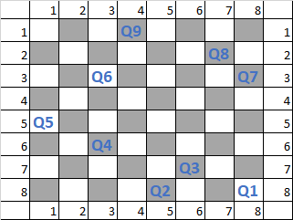  
There are total 9 Queens in the given scenario.  
**If you pick Q1,**  
It can kill 2 queens, if Path#1 (Q1 ==> Q6 ==> Q5) is followed  
It can kill 5 queens, if Path#2 (Q1 ==> Q7 ==> Q6 ==> Q4 ==> Q2 ==> Q3) is followed  
**If you pick Q3,**  
It can kill 7 queens, if Path#3 (Q3 ==> Q2 ==> Q1 ==> Q7 ==> Q8 ==> Q4 ==> Q6 ==> Q5) is followed  
Similarly, there can arise 'n' number of different paths if different Queens are chosen.  
The best path here is Path#3 that can kill 7 Queens & leaves only 2 queens on the board. So, 2 is the answer.

Input Format :

N,m  
I1,J1,Q1  
…  
…  
Im,Jm,Qm  
Input for above Problem:   
8,9  
8,8,Q1  
8,5,Q2  
7,6,Q3  
6,3,Q4  
5,1,Q5  
3,3,Q6  
3,8,Q7  
2,7,Q8  
1,4,Q9  
Answer: 2

Example2:  
In the below example, You can choose two Paths

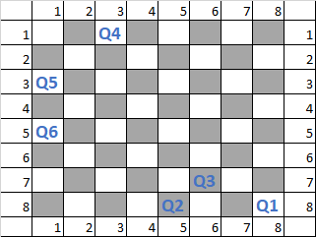  
Path#1 - Q1 -> Q2 -> Q3  
Path#2 - Q4 -> Q5 -> Q6  
But not both of them. After choosing either of the path, 1 + 3(from other path) remain on the table.  
So Answer here is 4.

Input for example2  
8,6  
8,8,Q1  
8,5,Q2  
7,6,Q3  
5,1,Q6  
3,1,Q5  
1,3,Q4

Output:  
4